Homework 5 – Warren Payne

1. SQL and Query:
   1. 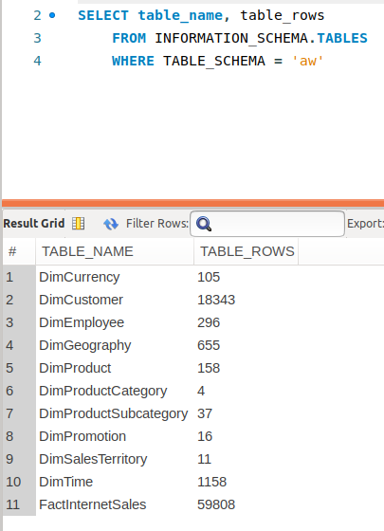
2. SQL and Query:
   1. 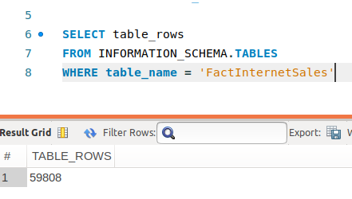
3. The designers named all Dimensional Tables with names starting with “Dim” and all Fact Tables with table names starting with “Fact”; albeit only one Fact Table in this case.
4. The reason for the recursive relationship in DimEmployee is likely to handle the case of an Employee having a Parent Employee (bosses). Thus, an instance of DimEmployee (a boss) may have one or many sub-instances of Dimemployee (lower-level employees). So, the table needs to be able to access other instances of itself.
5. Three bike models: Mountain Bikes, Road Bikes, Touring Bikes
   1. 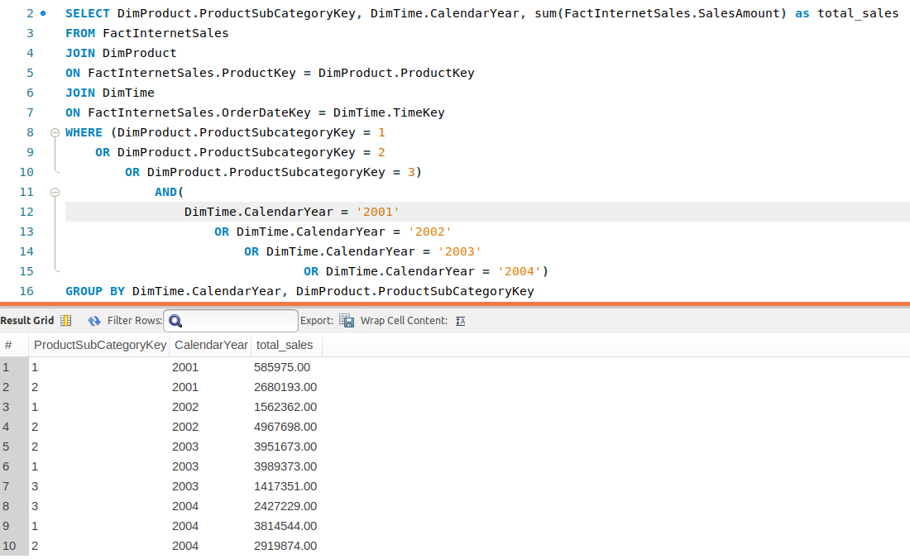
   2. ProductSubcategoryKey of 2 represents Road Bikes. So 2002 was the best year of sales for Road Bikes.
6. Code and the last of the 72 rows of the output

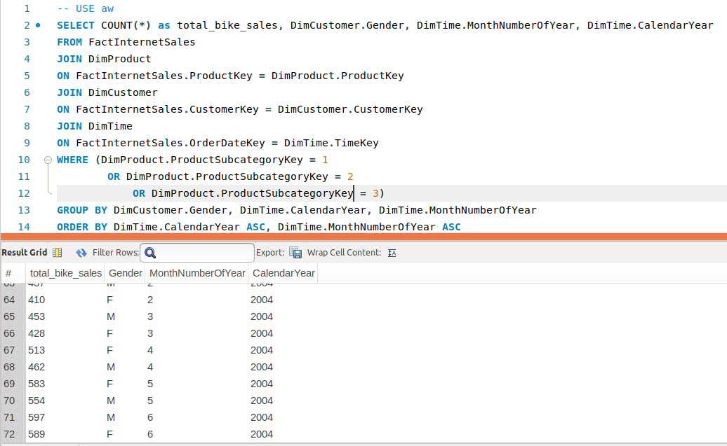

1. Note that I’ve assumed that profit can be calculated as: Product Sales Amount – ( ProductCost – tax amount – discount price)
   1. this is revenue – production cost (I think) – taxes owed – discount given
   2. Margin is given by the following: credit to <https://www.patriotsoftware.com/accounting/training/blog/margin-vs-markup-chart-infographic/#:~:targetText=To%20find%20the%20margin%2C%20divide%20gross%20profit%20by%20the%20revenue.&targetText=To%20make%20the%20margin%20a%20percentage%2C%20multiply%20the%20result%20by%20100.&targetText=The%20margin%20is%2025%25.,25%25%20of%20your%20total%20revenue.>
      1. 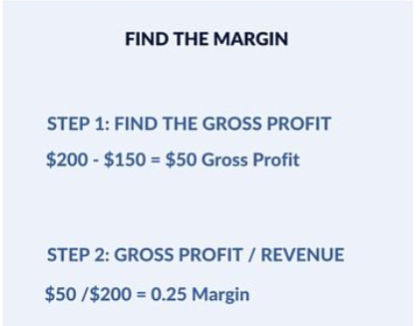
   3. Thus, the highest margin model from 2003 is the “Road Tire Tube”

